How to print approval from Encompass

- Click “Print” button

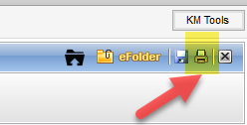

- Go to “Custom Forms” and select the form and click the “Add”buttom”

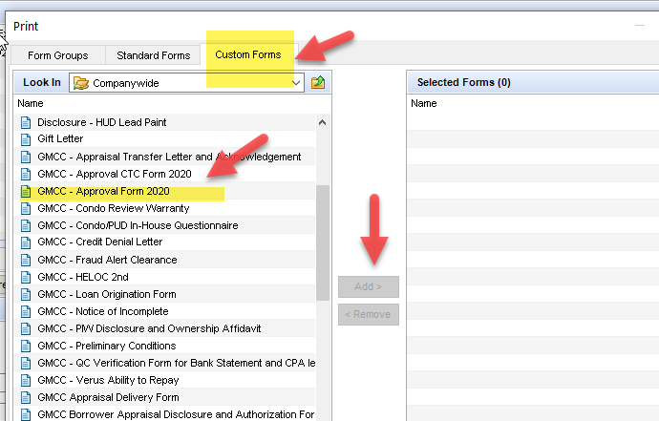

- Click “preview” or “Print”

